A128-Eur- Czech Republic-Těšetice-Kyjovice-Sutnách-Figurine**-**Venus**-**Headless, Legless-4,600 BCE

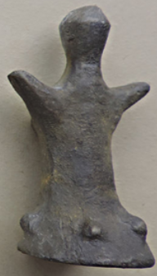 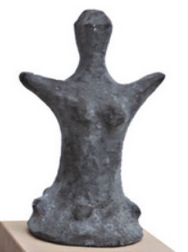

Case No.: 1

**Formal Label:** Eur- Czech Republic-Těšetice-Kyjovice-Sutnách-Figurine**-**Venus**-**Headless, Legless-4,600 BCE

**Display Description: The Sutnach site at** Těšetice-Kyjovice is located on the southern slope above the River Únanovkou. It was discovered in 1956 and excavated since 1967. It lies about 9 km northeast of Znojmo on the border of the municipalities of Kyjovice and Těšetice. This figurine has been sculpted in two volumes, a cylinder for the upper part and a cone for the lower part. The portion above the waist is apparently slender while the portion below the waist suggests the figure is wearing a flaring skirt as if dancing. This is further supported by her outstretched arms. The figurine has no facial features. This is a feature of many Sutnach female figurines.

**Accession Number: A127**

**LC Classification:** GN776.22.C95

**Date or Time Horizon:** 4,600 BCE-4,400 BCE

**Geographical Area:** Moravia (Czech Republic)

**Geographical Area:** Czech Republic-Těšetice-Kyjovice

**Map, GPS Coordinates:** 48.89567 16.13701, 40° 26' 46" N 79° 58' 56" W

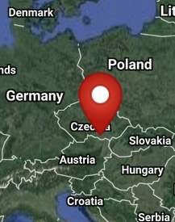 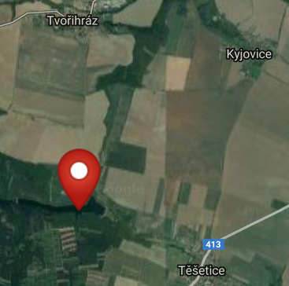

Maps of the location of the Sutnach site at Těšetice-Kyjovice from http://latitude.to/img/latitude-logo.svg.

**Cultural Affiliation:** Neolithic

**Medium:** Ceramic

**Dimensions: H** 65 mm; W 50 mm. **Weight:**

**Provenance:** Těšetice-Kyjovice 2

**Condition:** Museum Replica,TOP GEO, Satteldorf, Germany.

**Discussion:** TheSutnách site at Těšetice-Kyjovice was discovered by Prof. F. Kalousek 1956 during relief operations "Vinohrady" at Tesetice. Its location is situated between Těšetice and Kyjovice villages on a loess hill near Těšetičky / Únanovky Creek. Moravian painted pottery and stone tools, including obsidian were discovered in addition to Venus ceramic figurines. Since only agricultural work was carried out in the area, it can be assumed that the site and its archaeological objects are in good condition. The first systematic work was carried out in 1964, when it was found that the site is very large (about 12 ha) and bears traces of the Neolithic period, the Bronze Age and Hallstatt.

**References:**

Department of Archaeology and Museology. 2014. The history of research on "Sutnách" at Těšetice-Kyjovice [online]. Brno: Spisy University.

# Pavlů, Ivan and M. Zápotocká. 1978. *Analysis of the Czech Neolithic pottery: morphological and chronological structure of projections* [přel. H. Tichá; tabule kresby, Z. Kříž, T. Mazálková]. Prague: [Academia].

# Podborský, Vladimir. 1985. *Těšetice-Kyjovice II.* Figurální Plastika Lidu S Moravskou Malovanou Keramikou*.* Brno: Spisy University J.E. Purkyně v Brně, Filosofická fakulta.